1. At very low temperatures, the molar specific heat c of many solids is approximately $c=AT^{3}$, where A depends on the particular substance. For aluminum $A={3,15.10}^{-5}$ J/mol. $K^{4}$. Find the entropy change for 4.00 mol of aluminum when its temperature is raised from 5.00 K to 10.0 K.
2. A 364 g block is put in contact with a thermal reservoir. The block is initially at a lower temperature than the reservoir. Assume that the consequent transfer of energy as heat from the reservoir to the block is reversible. **Figure 1** gives the change in entropy $∆S$ of the block until thermal equilibrium is reached. The scale of the horizontal axis is set by $T_{a}= 280 K$ and $T_{b}= 380$ K.

What is the specific heat of the block?

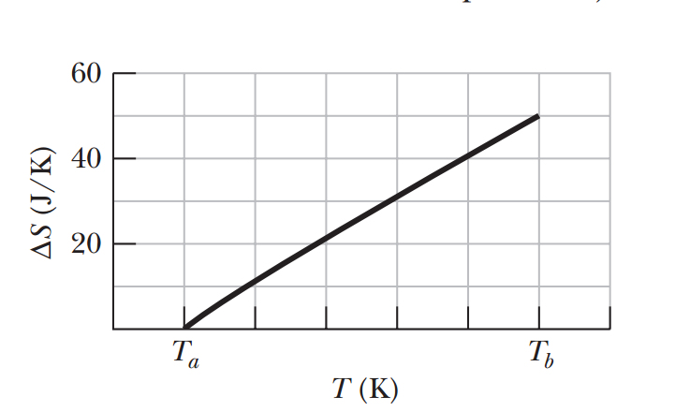

Figure 1.

1. In an experiment, 200 g of aluminum (with a specific heat of 900 J/kg.K) at 100°C is mixed with 50.0 g of water (specific heat of 4190 J/kg.K) at 20.0°C, with the mixture thermally isolated. (a) What is the equilibrium temperature? What are the entropy changes of (b) the aluminum, (c) the water, and (d) the aluminum–water system?
2. A gas sample undergoes a reversible isothermal expansion. **Figure 2** gives the change $∆S$ in entropy of the gas versus the final volume $V_{f}$ of the gas. The scale of the vertical axis is set by $∆S= 64$ J/K.

How many moles are in the sample?

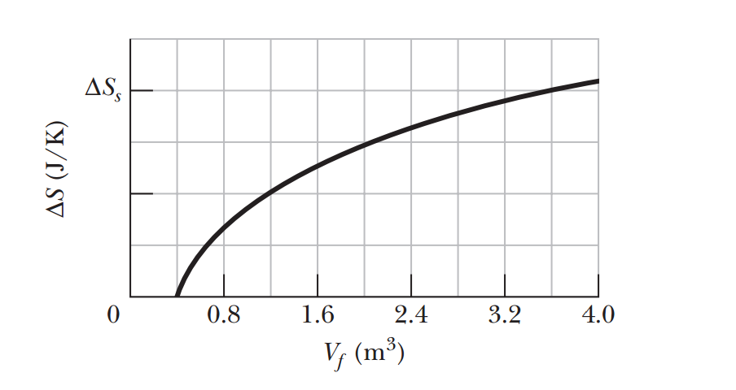

Figure 2.

1. One mol of a monatomic ideal gas taken through the cycle in **Figure 3**, where $V_{1}=4V_{0}$,

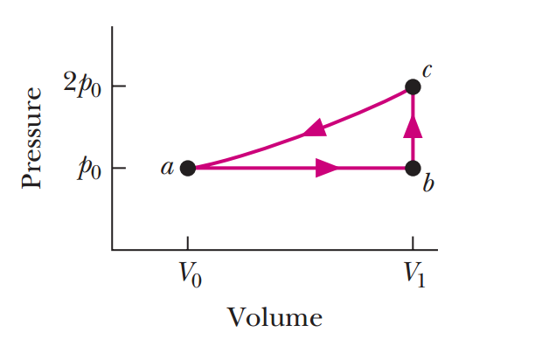

Figure 3.

1. what is $W/p_{0}V_{0}$ as the gas goes from state a to state c along path abc?
2. What is $∆E_{int}/p_{0}V_{0}$ in going from b to c and through one full cycle?
3. What is $∆S$ in going from b to c and through one full cycle?
4. A mixture of 1773 g of water and 227 g of ice is in an initial equilibrium state at 0°C. The mixture is then, in a reversible process, brought to a second equilibrium state where the water–ice ratio, by mass, is 1:1at 0°C.
5. Calculate the entropy change of the system during this process. (The heat of fusion for water is 333 kJ/kg).
6. The system is then returned to the initial equilibrium state in an irreversible process (say, by using a Bunsen burner). Calculate the entropy change of the system during this process.
7. Are your answers in part (a) consistent with the second law of thermodynamics?
8. The cycle in **Figure 4** represents the operation of a gaso line internal combustion engine. Volume $V_{3}= 4V_{1}$. Assume the gasoline–air intake mixture is an ideal gas with $γ=$ 1.3.

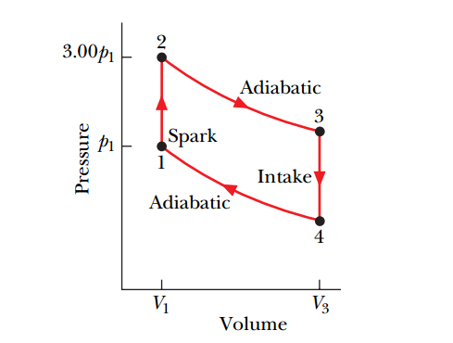

Figure 4.

What are the ratios

1. T2/T1.
2. T3/T1.
3. T4/T1.
4. p3/p1.
5. p4/p1.
6. One mol of an ideal gas is the working substance in an engine that operates on the cycle shown In **Figure 5**.

Processes BC and DA are reversible and adiabatic.

Is the gas monatomic, diatomic, or polyatomic?.

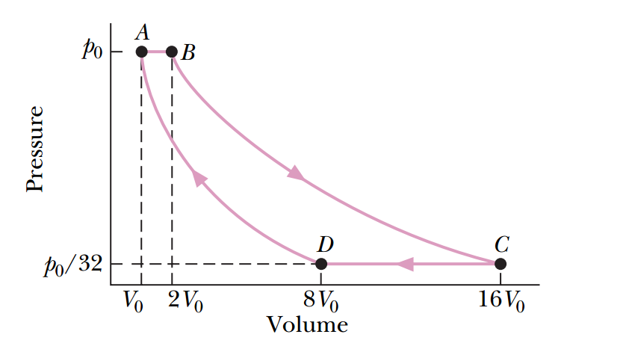

Figure 5.

1. 0.03675 J/K.
2. 450 J/kg.K.
3. (a) 59.97 $℃$; (b) -22.06 J/K; (c) 24.89 J/K; (d) 2.83 J/K.
4. 3.5 mol.
5. (a) 3; (b) 6 and 0; (c) 2.84 J/K and 0 J/K.
6. (a) -942.89 J/K; (b) 942.89 J/K; (c) Hint: unclosed systems.
7. (a) 3; (b) 1.979; (c) 0.6597; (d) 0.4948; (e) 0.1649.
8. f = 3 $→$ monatomic